- Display the total number of employee working in the company.
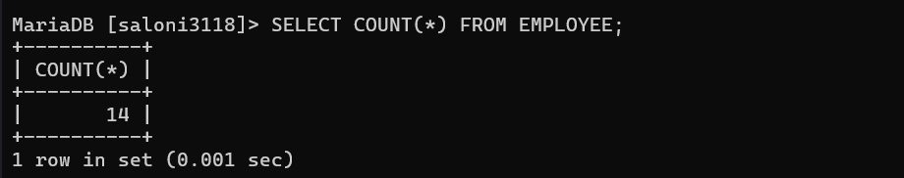
- Display the total salary being paid to all employees.
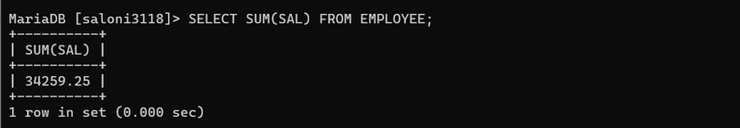
- Display the maximum salary from employee table.
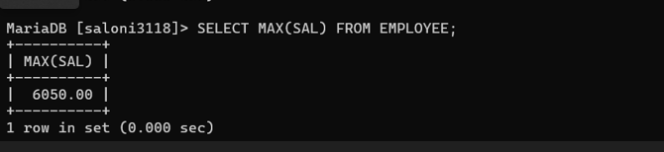
- Display the minimum salary from employee table.
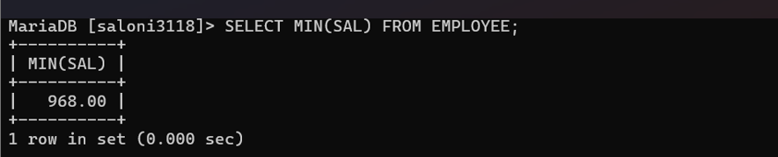
- Display the average salary from employee table
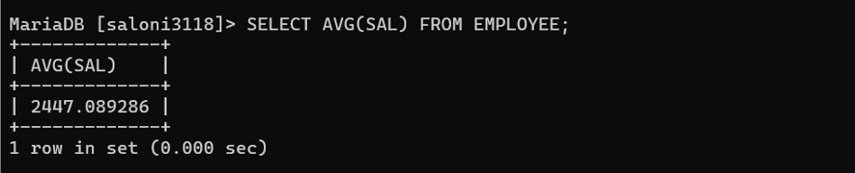
- Display the maximum salary being paid to clerk.
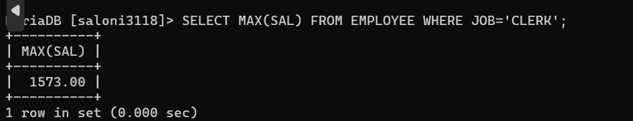

- Display the maximum salary being paid in dept no 20.
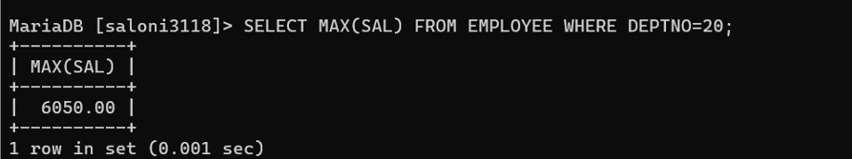8. Display the minimum salary paid to any salesman.
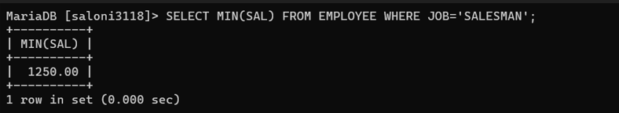
- Display the average salary drawn by managers.
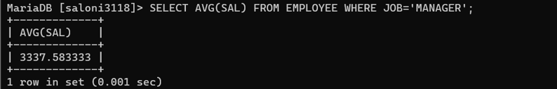
10.Display the total salary drawn by analyst working in dept no 40
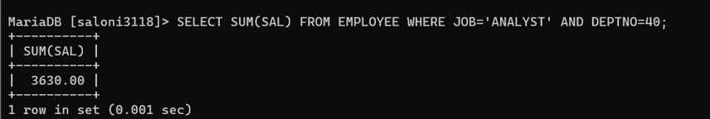

- Display the names of the employee in Uppercase.
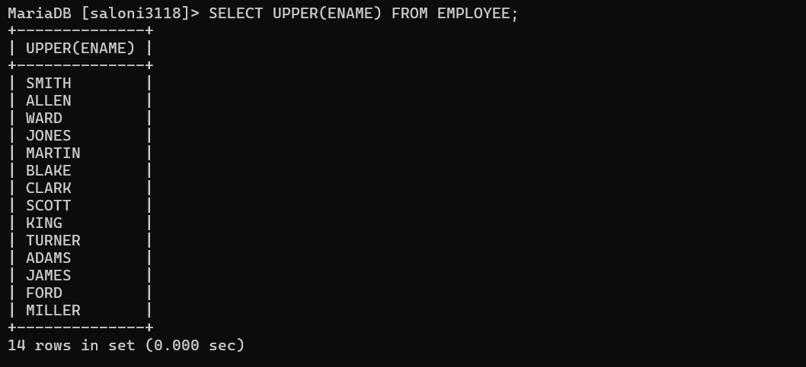

- Display the names of the employee in Lowercase.
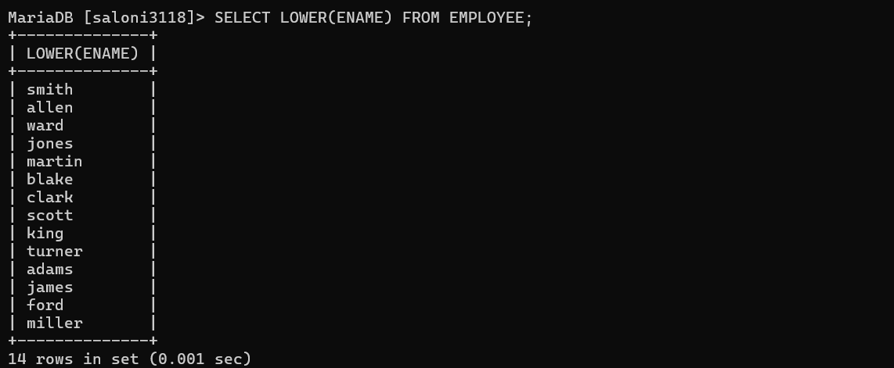

- Display the names of the employee in Proper case.
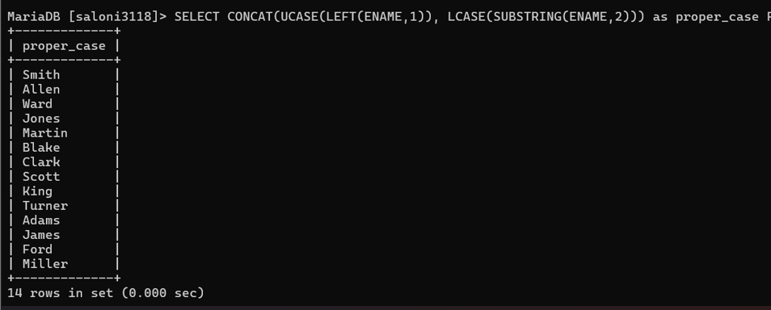
- Display the length of Your name using appropriate function.
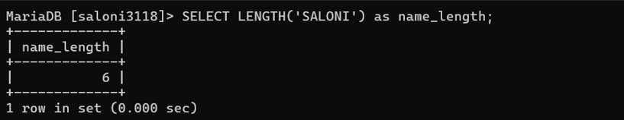
- Display the length of all the employee names.
